
PALM BEACH COUNTY DARTING ASSOCIATION

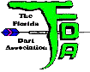
23rd ANNUAL WINTER FLING
$2,000
FEBRUARY 4, 2012

* $1.00 FDA & $2.00 ADO per singles entry Registration cutoff 15 minutes before each match Steel tip darts only
SATURDAY  EVENT | OPEN  SINGLES  CRICKET | LADIES  DOUBLES  CRICKET | MEN’S  DOUBLES  CRICKET | MIXED  DOUBLES  501 | LADIES  SINGLES  501 | MEN’S  SINGLES  501
TIME | 10:30am | 11:30am | 1:00pm | 3:00pm | 4:00pm | 4:30pm
ENTRY | $18 | $26 | $26 | $26 | $17* | $17*
1ST | $300 | $120 | $150 | $150 | $120 | $160
2ND | $100 | $70 | $100 | $100 | $70 | $80
3RD – 4TH | $50 | $30 | $50 | $50 | $20 | $40
TOTAL | $500 | $250 | $350 | $350 | $230 | $320
FDA membership required – Weekend membership available

LOCATION: CONTACTS:
The Blue Boar Becky Jordan Steve Lambiase
1306 N Military Tr. (561) 371-0133 (561) 704-3268
West Palm Beach Dartldy@bellsouth.net Ebchops3@yahoo.com

I-95 to Belvedere Rd, West to Military, North about 0.2 miles on right
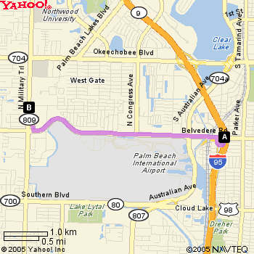

Note: Entry fees are processing fees for Tournament Management
Administration and advertising. Prize monies are paid by the
tournament sponsor and are not part of the processing fees. This
meets the criteria of the Florida Gaming Laws. Prize monies are
guaranteed by PBCDA.

